**TASK 8 – Part B (Presentation)**

**Teacher name: Ms Lauren Barrie**

***Part B Presentation of findings (18 marks)***

* Create a presentation to highlight the key points of your findings
* Use historical sources (Primary AND Secondary) to support your findings

_____________________________________________________________________________________________

**FORMAT – Museum Display**

Objects and specimens help bring history to life, make connections between the past and present, record biological diversity, and provide data for researchers. Museums collect objects, care for them, and use them to help people understand the world around them.

Museum collections teach us about our world.

Exhibit designers and museum curators tell stories by choosing which objects to display and how to present them.

**Your Task**

Create a ‘Museum Exhibit’ that demonstrates the power and influence of your selected individual. You are not simply including sources about your person, but choosing primary (from the time of their life) and secondary (after their death) sources that demonstrate their **power and influence**.

Primary sources may include speeches, paintings, artefacts, quotes etc.  
Secondary sources may include articles, paintings, historian textbooks etc.

**Criteria**

Include the following –

* An overview of your person (key information)
* Two PRIMARY sources with explanations about the source, and how it demonstrates their power and influence
* Two SECONDARY sources with explanations about the source, and how it demonstrates their power and influence

**Materials:**

* Historical Sources (printed photos) – must include PRIMARY and SECONDARY sources
* Museum Exhibit Templates
* Museum Display
* Blank Paper
* Pencils/Coloured Textas
* Scissors
* Glue

**Museum Exhibit Examples**

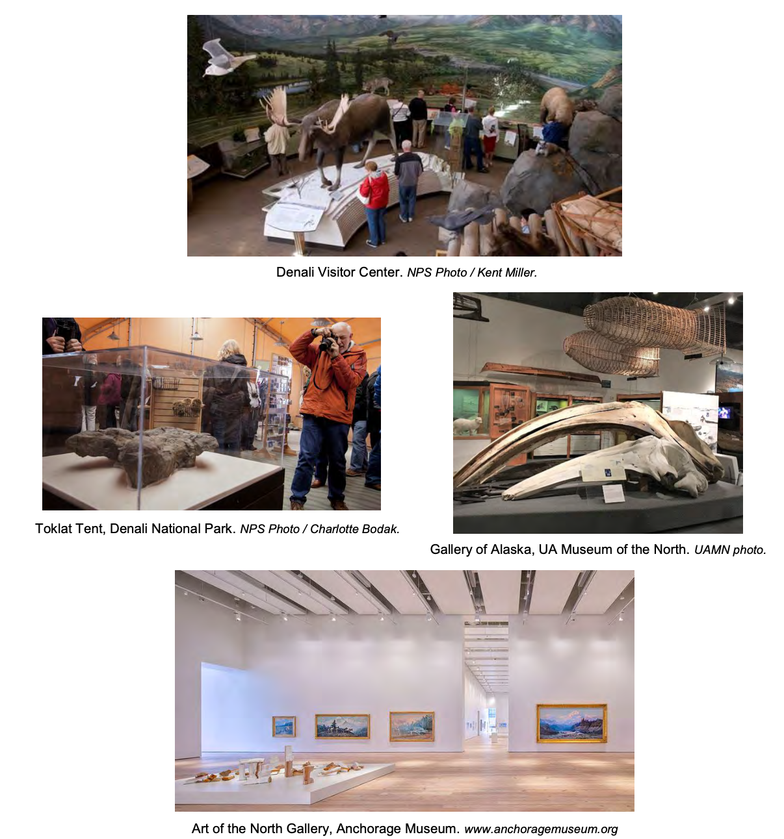

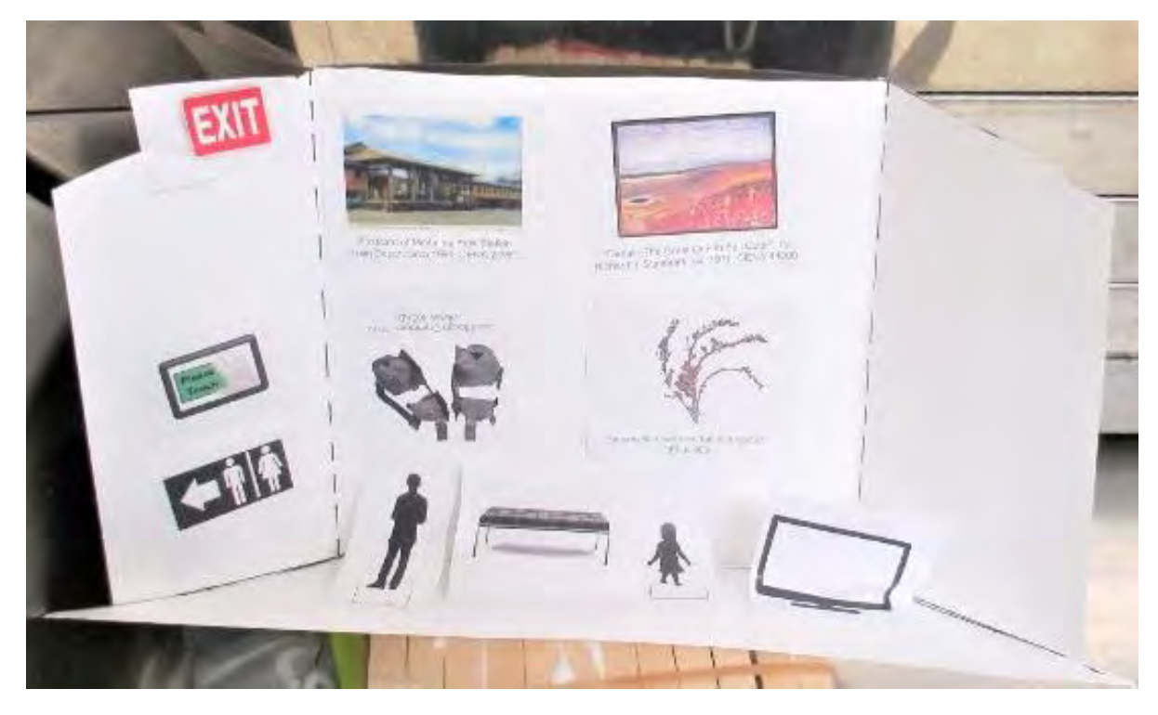**Primary School Example:**

**Draft/Plan your Exhibit Below:**

